**PowerAfrica Paper Template**

John Doe

Senior Member, IEEE

University of Texas

1 Main Street

Houston, TX 12345, USA

John.doe@utexas.comJeanne Dupont

Université de Kinshasa

Kinshasa, Democratic Republic of Congo

J.dupont@ieee.orgJack W. Smith

ABC Corporation, Ltd.

100 Independence Street

Nairobi, Kenya

Jack.w.smith@abc.ke

*Abstract* -- This document is an example of the preferred layout of IEEE conference papers (inclusive of this abstract). It can also be used as a template. The document contains information regarding desktop publishing format, type sizes, and typefaces. Style rules are provided that explain how to handle equations, units, figures, tables, abbreviations, and acronyms. Sections are also devoted to the preparation of acknowledgments and references. The abstract should not exceed 150 words and cannot contain equations, figures, tables, or references. It should concisely state what was done, how it was done, principal results, and their significance. The format applies to both regular submissions and “short paper”, although a section is included at the end to highlight the possible modifications for the short papers.

*Index Terms*--The author should provide up to 10 keywords (in alphabetical order) to help identify the major topics of the paper. The thesaurus of IEEE indexing keywords should be referenced prior to selecting the keywords to ensure that the words selected are acceptable. The thesaurus 2009 IEEE Taxonomy is posted at

http://www.ieee.org/organizations/pubs/ani_prod/keywrd98.txt.

# Nomenclature

A nomenclature list, if needed, should precede the Introduction.

# Introduction

This document provides an example of the desired layout and can be used as a Microsoft Word template. It contains information regarding desktop publishing format, style rules, and the preparation of various special sections. The electronic manuscript you prepare will be reproduced without further editing in the PowerAfrica Proceedings (or Conference Record). For additional information, please refer for instance to the Information for Authors available on the IAS web site at http://ias.ieee.org.

## Technical Work Preparation

Please use automatic hyphenation and check your spelling. Additionally, be sure your sentences are complete and that there is continuity within your paragraphs. Check the numbering of your graphics (figures and tables) and make sure that all appropriate references are included.

## Template

This document was designed to be used as a template. . You may then type over sections of the document, cut and paste into it (Edit | Paste Special | Unformatted Text), and/or use markup styles. The pull-down style menu is at the left of the Formatting Toolbar at the top of your Word window (for example, the style at this point in the document is "Text"). Highlight a section that you want to designate with a certain style, then select the appropriate name on the style menu.

## Format

The standard format for IEEE conference papers is the two column format illustrated by this template document.

Occasionally, authors encounter problems with content that doesn’t conveniently fit into the two column format. It is acceptable to switch short sections of the manuscript to single-column to accommodate figures or equations that won’t fit into a single column of a double-column page (ie, so that the material spans both columns on the page). And it is also acceptable to rotate individual figures 90o in the counterclockwise direction to fit onto a full page. However, text should never be rotated on the page.

Set top and bottom margins to 25.4 mm (1 inch) and left and right margins to about 18 mm (0.7 inches)[1] Do not violate margins (i.e., text, tables, figures, and equations may not extend into the margins). The column width is 88 mm (3.45 inches). The space between the two columns is 5 mm (0.2 inches). Paragraph indentation is 5 mm. Use full justification. Use either one or two spaces between sections, and between text and tables or figures, to adjust the column length. Do not include headers, footers, or page numbers.

## Use of Color

Author’s manuscripts will be reproduced directly into the PowerAfrica Conference Record. It is commonplace for Conference Records to be electronic, and in those instances, it is possible to include color in the manuscript. However, it is good practice, whenever possible, to design figures to be legible when reduced to grayscale.

In general, the use of color should be limited to figures only. Text may not be in color, and color shading is never acceptable.

## Typefaces and Sizes

Please use a proportional serif typeface such as Times Roman or Times New Roman and embed all fonts. Table I provides samples of the appropriate type sizes and styles to use.

TABLE I

Samples of Times Roman Type Sizes and Styles

|  |  |  |  |
| --- | --- | --- | --- |
| Type size (pts) | Appearance | | |
| Regular | Bold | Italic |
| 6 | Table subscripts and superscripts |  |  |
| 8 | References, tables, tables names*, figure captions, footnotes, text subscripts and superscripts |  |  |
| 9 |  | Abstract |  |
| 10 | Section headings*, main text, authors’ affiliations, equations |  | Sub-headings |
| 14 | Authors’ names | Paper Title |  |

*Small caps

## Section Headings

A primary section heading is enumerated by a Roman numeral followed by a period and is centered above the text. A primary heading should be in capital letters.

A secondary section heading is enumerated by a capital letter followed by a period and is flush left above the section. The first letter of each important word is capitalized and the heading is italicized.

A tertiary section heading is enumerated by an Arabic numeral followed by a parenthesis. It is indented and is followed by a colon. The first letter of each important word is capitalized and the heading is italicized.

A quaternary section heading is rarely necessary, but is perfectly acceptable if required. It is enumerated by a lowercase letter followed by a parenthesis. It is indented and is followed by a colon. Only the first letter of the heading is capitalized and the heading is italicized.

## Figures and Tables

Figure axis labels are often a source of confusion. Try to use words rather than symbols. As an example, write the quantity "Magnetization," or "Magnetization, *M*," not just "*M*." Put units in parentheses. Do not label axes only with units. As in Fig. 1, write "Magnetization (kA/m)" or "Magnetization (kA·m-1)," not just "kA/m." Do not label axes with a ratio of quantities and units. For example, write "Temperature (K)," not "Temperature/K." Figure labels should be legible, approximately 8- to 10-point type.

Large figures and tables may span both columns, but may not extend into the page margins. Figure captions should be below the figures; table captions should be above the tables. Do not put captions in "text boxes" linked to the figures. Do not put borders around your figures.

All figures and tables must be in place in the text near, but not before, where they are first mentioned. Use the abbreviation "Fig. 1," even at the beginning of a sentence.

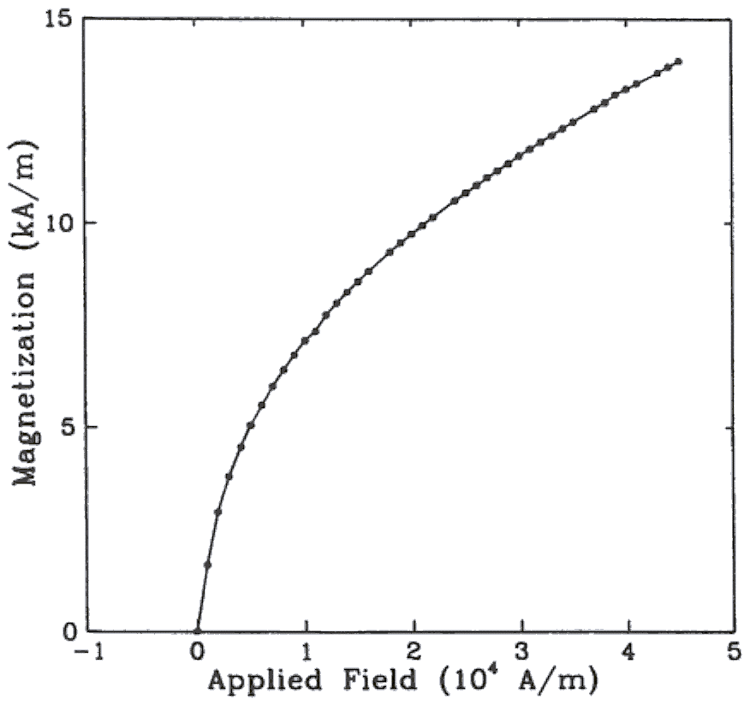

Fig. 1. Magnetization as a function of applied field

Note that "Fig." is abbreviated and there is a period after the figure number followed by two spaces

The caption is centered in the column

Compound figures contain two or more elements in a single numbered figure. The elements within a compound figure may be individually numbered, and may be referred to in the text by that number (eg, Fig. 1a). However, if you add a figure to your manuscript before submitting it, be sure to assign that figure a unique identification, and renumber the other figures, and their callouts, as necessary.

The process of embedding figures (and tables) in the manuscript depends to a great extent on constraints imposed by the word processing tool used to create the manuscript. Papers are converted to the Portable Document Format for both the conference record and to be archived in IEEE Xplore. Incorrectly embedded figures can confound the pdf distillation process. Many authors use Microsoft Word, and the suggestions below generally work well with that tool. Each figure should be prepared in its entirety using an appropriate graphics tool. In this respect, don’t superimpose text or graphics over an embedded figure using either the “Draw” or “Text Box” features of Word.

There are generally two approaches to embedding figures in a Word document – either the Insert | Pictures_ or the Copy | Paste approach. Insert | Pictures is almost always successful, and the graphics may originate as .jpg, .gif, .bmp, .eps or .tif files. Copy | Paste is more likely to be successful if the “Paste Special” option is chosen, and figures are embedded as “enhanced metafiles”.

It is a good idea to test the integrity of your figures by doing a pdf distillation prior to submitting the manuscript using Adobe Acrobat.

## Numbering

Number reference citations consecutively in square brackets [1]. The sentence punctuation follows the brackets [2]. Multiple references [2], [3] are each numbered with separate brackets [1]-[3]. Refer simply to the reference number, as in [3]. Do not use "Ref. [3]" or "reference [3]" except at the beginning of a sentence: "Reference [3] shows….".

Number footnotes separately with superscripts (Insert | Footnote). Place the actual footnote at the bottom of the column in which it is cited. Do not put footnotes in the reference list. Use letters for table footnotes.

Check that all figures and tables are numbered correctly. Use Arabic numerals for figures and Roman numerals for tables.

Appendix figures and tables should be numbered consecutively with the figures and tables appearing in the rest of the paper. They should not have their own numbering system.

## Units

Metric units are strongly encouraged for use in IEEE publications in light of their global readership and the inherent convenience of these units in many fields. In particular, the use of the International System of Units (“Système International d'Unités” or SI Units) is advocated. This system includes a subsystem of units based on the meter, kilogram, second, and ampere (MKSA). British units may be used as secondary units (in parentheses). An exception is when British units are used as identifiers in trade, such as 3.5-inch disk drive.

## Abbreviations and Acronyms

Define less common abbreviations and acronyms the first time they are used in the text, even after they have been defined in the abstract. Abbreviations such as IEEE, SI, MKS, CGS, AC, DC, and *rms* do not have to be defined. Do not use abbreviations in the title unless they are unavoidable. This said, it is good practice to minimize the use of abbreviations and acronyms.

## Math and Equations

Use either the Microsoft Equation Editor or the *MathType* commercial add-on for MS Word for all math objects in your paper (Insert | Object | Create New | Microsoft Equation *or* MathType Equation). "Float over text" should *not* be selected.

To make your equations more compact, you may use the solidus ( / ), the exp function, or appropriate exponents. Italicize Roman symbols for quantities and variables, but not Greek symbols. Use a long dash rather than a hyphen for a minus sign. Use parentheses to avoid ambiguities in denominators.

Number equations consecutively with equation numbers in parentheses flush with the right margin, as in (1). Be sure that the symbols in your equation have been defined before the equation appears or immediately following.

(1)

where *IF* is the fault current.

Use "(1)," not "Eq. (1)" or "equation (1)," except at the beginning of a sentence: "Equation (1) is .…".

## Originality of Content

Plagiarism in any form is expressly forbidden, and the content of your paper should be totally original. This includes material you previously published. However, there are situations where it is appropriate to include quoted material in technical papers.

If you copy text from other sources, you must clearly differentiate copied text from original text that you actually write. Quotation marks are the best way to identify quoted material, but you may also delineate such material by using a different type face or indentation. You must also clearly cite the source from which the quoted text was taken.

Copying figures is more involved. IEEE requires that you include the phrase “© XXXX, reprinted by permission” on figures that you copy from published sources, that you obtain written permission from the person or entity that owns the copyright for the source from which the figure was taken, and that you cite that source as a reference.

## Author information

Contributors to the paper should be listed immediately below the title of the paper as illustrated in this template. The author information shown in the manuscript should reflect the affiliation of each author at the time the paper was originally written. Including an e-mail address for each author is not mandatory, but is a convenience for readers of the paper.

It is not necessary to include author biographies. If choosing to do so, limit them to 200 words each, and place them after the references.

Occasionally, papers are written by large groups of people. One example would be a Standard Working Group. Such papers are subject to the same rules as papers written by individual authors or groups of authors. The only practical consideration is that rather than listing all of the authors of a working group paper under the manuscript title, the membership of the working group may be listed in either a block of text placed at the bottom of the left column on the first page of the manuscript, or in the acknowledgement at the end of the manuscript.

# Short Papers

Shorter papers are welcome at PowerAfrica, alongside regular technical submissions. Short papers are typically focused on case studies or application examples. Their formatting is identical to that of regular submissions, but a number of sections expected or mandatory in regular submissions are now optional. For instance, a nomenclature is unlikely, and the list of references may be quite short.

# Publication in Transactions

Every paper accepted at PowerAfrica will be uploaded to IEEE Xplore after the conference, where it will be identified as being part of the conference record for the year it was presented. On occasion however, authors may want to follow their presentation with submitting the paper manuscript for publication in an IEEE Transactions or Magazine. The following is a general guidance for those interested in pursuing this route.

IEEE has the most comprehensive offering of Transactions in the field of electrical engineering. Transactions papers are expected to be of higher quality than conference papers, understood in terms of breadth of the study, inclusion of theoretical as well as experimental work, explaining where the contribution stands with respect to the existing art, etc. This said, it is often the case that a Transactions paper starts initially as a conference paper, or is a combination of several conference papers. In fact, some IEEE societies, such as the IAS, require for a paper to be presented first at a conference.

Papers presented at PowerAfrica can be a good source for a potential Transactions paper. For authors interested in publishing in Transactions after PowerAfrica, there are several steps to take:

1) Add material, combine several papers, and generally enhance the paper to make it ready for peer review.

2) Select the most appropriate transactions. Very likely Transactions for PowerArica papers, this would be Transactions from the IEEE Power and Energy Society [12] or the Transactions on Industry Applications [13].

The recommendation is therefore to look at the scope of the various possible transactions. If not clear, feel free to contact the editor of the Transactions you are considering, and ask if your topic is within its scope.

# Appendix

Appendixes, if needed, appear before the acknowledgment.

# Acknowledgment

The following is an example of an acknowledgment. (Please note that financial support should be acknowledged in an unnumbered footnote on the title page).

The authors gratefully acknowledge the contributions of I.X. Austan, A.H. Burgmeyer, C.J. Essel, and S.H. Gold for their work on the original version of this document.

# References

References are important to the reader; therefore, each citation must be complete and correct. There is no editorial check on references; therefore, an incomplete or wrong reference will be published and will detract from the authority and value of the paper. References should be readily available publications.

If the source is written in a language other than English, mention the language in italics and in parentheses at the end. For instance: *(in French).*

Articles found on the web generally follow the same rules. However, it is important to add the date when the article was last accessed by the authors, as webpages are susceptible to change over time. If there is no author name, the web source title should be enclosed in double quotation marks.

Samples of the correct formats for various types of references are given below.

*Periodicals:*

1. J. F. Fuller, E. F. Fuchs, and K. J. Roesler, "Influence of harmonics on power distribution system protection," *IEEE Trans. Power Delivery*, vol. 3, pp. 549-557, Apr. 1988.
2. E. H. Miller, "A note on reflector arrays," *IEEE Trans. Antennas Propagat.*, to be published.

*Books:*

1. E. Clarke, *Circuit Analysis of AC Power Systems*, vol. I. New York: Wiley, 1950, p. 81.
2. G. O. Young, "Synthetic structure of industrial plastics," in *Plastics*, 2nd ed., vol. 3, J. Peters, Ed. New York: McGraw-Hill, 1964, pp. 15-64.

*Technical Reports:*

1. E. E. Reber, R. L. Mitchell, and C. J. Carter, "Oxygen absorption in the Earth's atmosphere," Aerospace Corp., Los Angeles, CA, Tech. Rep. TR-0200 (4230-46)-3, Nov. 1968.

*Papers Presented at Conferences (Unpublished):*

1. D. Ebehard and E. Voges, "Digital single sideband detection for interferometric sensors," presented at the 2nd Int. Conf. Optical Fiber Sensors, Stuttgart, Germany, 1984.

*Papers from Conference Proceedings (Published):*

1. J. L. Alqueres and J. C. Praca, "The Brazilian power system and the challenge of the Amazon transmission," in *Proc. 1991 IEEE Power Engineering Society Transmission and Distribution Conf.*, pp. 315-320.

*Dissertations:*

1. S. Hwang, "Frequency domain system identification of helicopter rotor dynamics incorporating models with time periodic coefficients," Ph.D. dissertation, Dept. Aerosp. Eng., Univ. Maryland, College Park, 1997.

*Standards:*

1. *IEEE Guide for Application of Power Apparatus Bushings*, IEEE Standard C57.19.100-1995, Aug. 1995.

*Patents:*

1. G. Brandli and M. Dick, "Alternating current fed power supply," U.S. Patent 4 084 217, Nov. 4, 1978.

*On-line articles:*

[11] IEEE Periodicals Transactions/Journals Department, “IEEE Reference Guide”, v11.12.2018, 2018. [Online]. Accessed on: March 1, 2021. Available: https://ieeeauthorcenter.ieee.org/wp-content/uploads/IEEE-Reference-Guide.pdf.

[12] “PES Transactions”. [Online]. Accessed on: April 11, 2021. Available: https://www.ieee-pes.org/publications/transactions.

[13] “ IEEE Transactions on Industry Applications”. [Online]. Accessed on: April 1, 2021. Available: https://ias.ieee.org/publications/ieee-transactions-on-industry-applications.html.

1. The margin dimensions correspond to paper size 8.5”x11”, please adjust accordingly for A4 or other paper source.